***Experiment 10 Output***

Real-time data warehousing with **streaming integration**. Continuously ingest and store live data for dynamic analysis. Implement **efficient data handling** and **visualization**.

***Creating Database and Data Table***

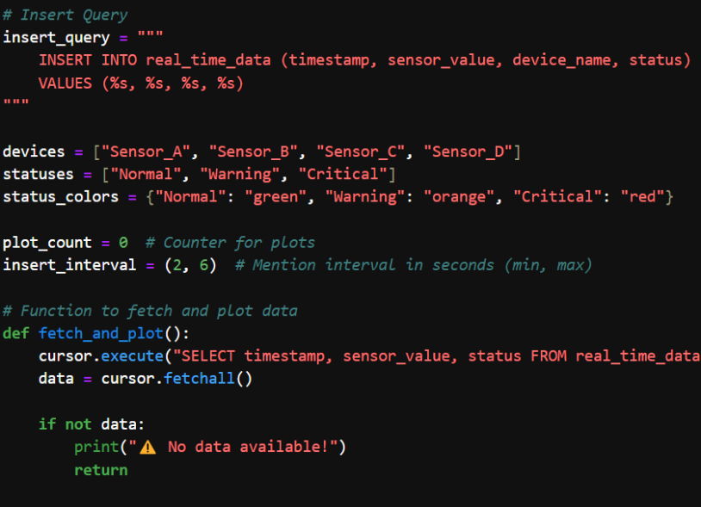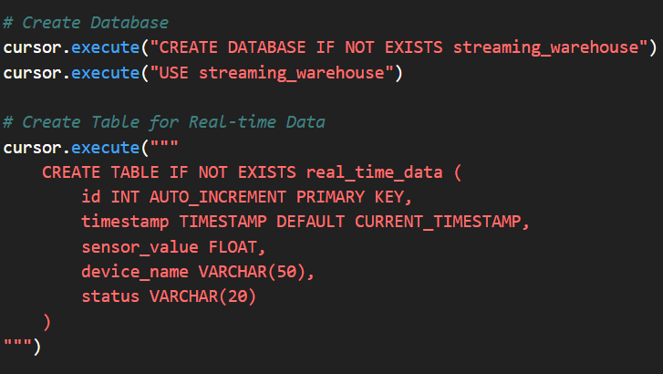

***Inserting Data Via SQL and Python***

***Fig 2: Data Insertion***

***Fig 1: Database and Table Creation***

***Plots Showing Streaming Data Status***

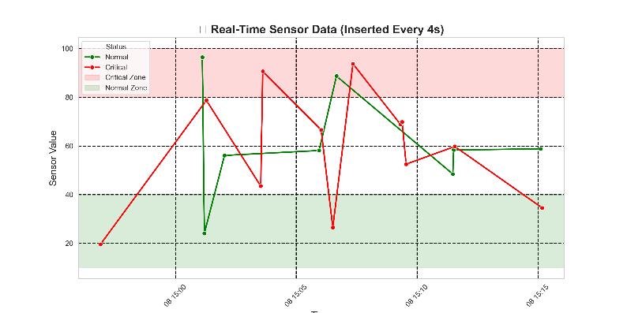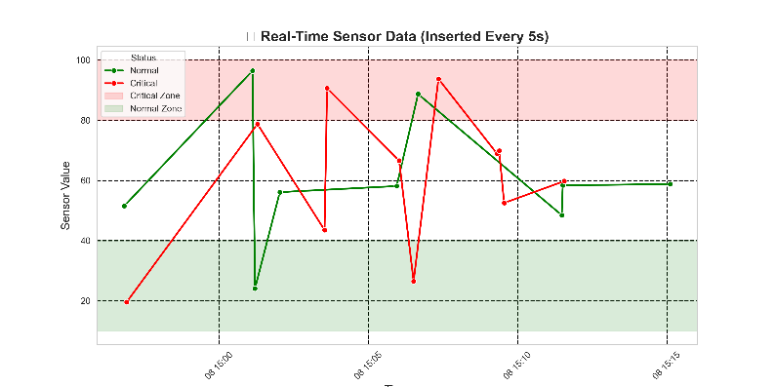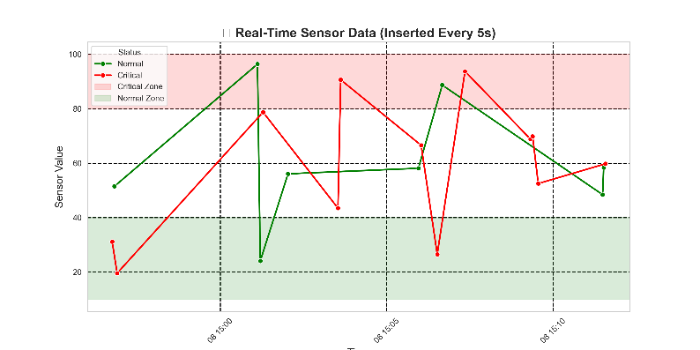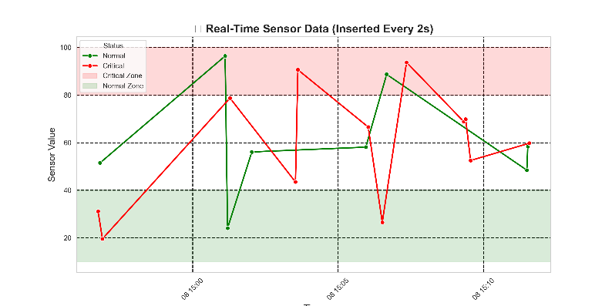

***Fig 3: Sensor Distribution Graph***